**BIBD MINI PROJECT**

* **Start mongodb**

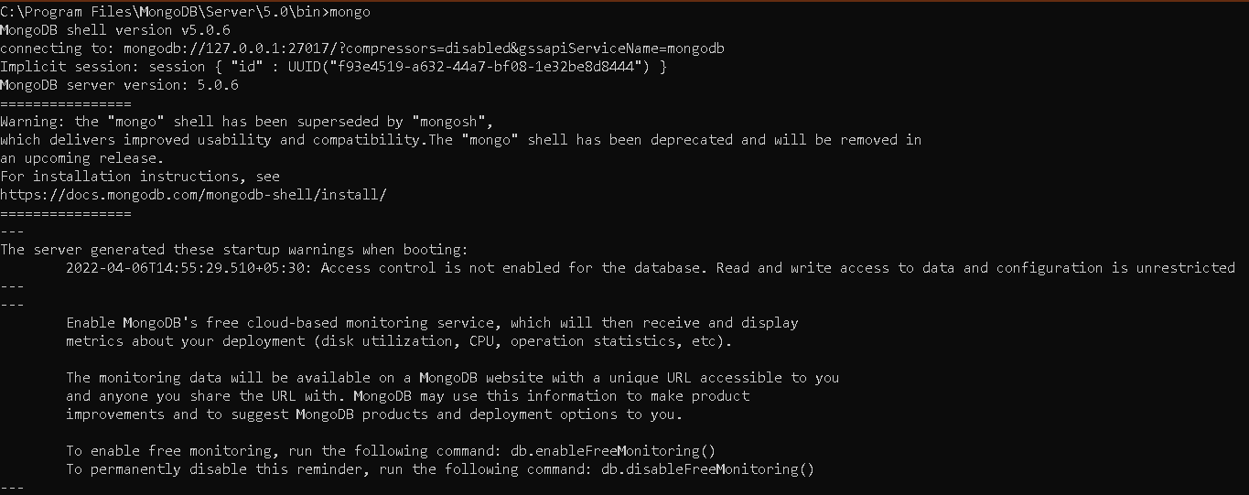

* **show dbs command (lists out all the databases)**

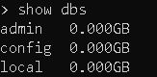

* **use miniproject(creates a database named miniproject)**



* **insertMany() (used to insert details into a collection)**

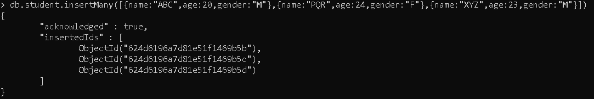

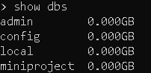

* **show collections (lists out all the collections in a db)**



* **find() (views the records in a collection)**

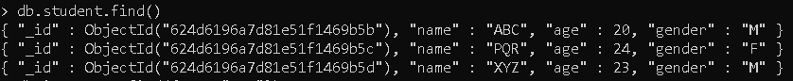

* **Display the records of the student with age “24”**



* **Display the records of students where age is greater than 20**



* **Display all records where gender is not male**



* **Display the records where name starts with “A” or age is lesser than 24**



* **pretty() (displays the records in a more readable format)**

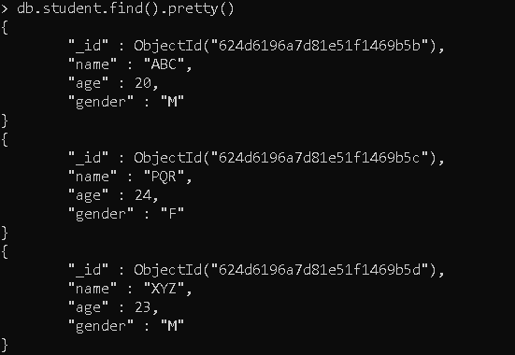

* **updateMany() (used to update multiple records)**

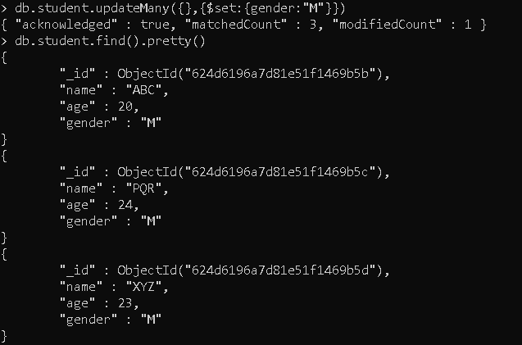

* **deleteMany() (used to delete multiple records)**

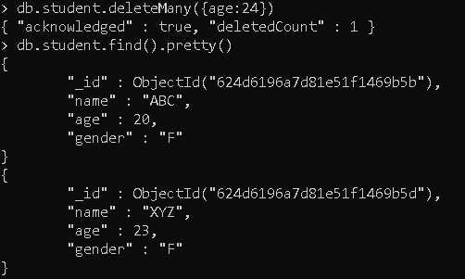

* **db.collectionname.drop() (used to delete a collection)**



* **db.dropDatabase() (used to delete a database)**

